Individual Essentials your new Boy Scout will need:
1. Mess Kit: We wash our own dishes and teach proper cleaning and disinfecting out on the trail. He will need a mess kit that consists of plate, bowl, utensil set. As they get older, you may consider a one person metal pot set that doubles as a plate/bowl since they can heat their meal up on a stove while backpacking. Knife, fork, spoon kits can be plastic or metal. The metal stainless steel seem to hold up longer.
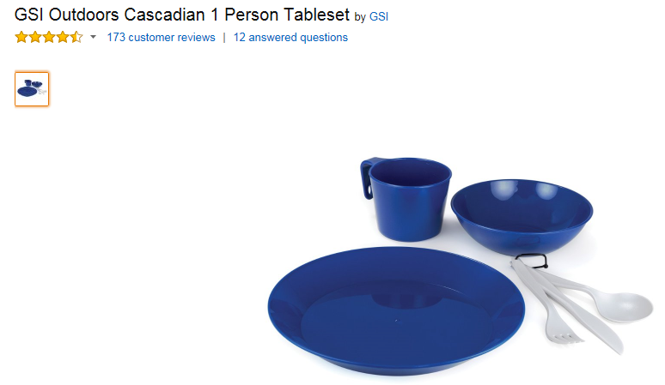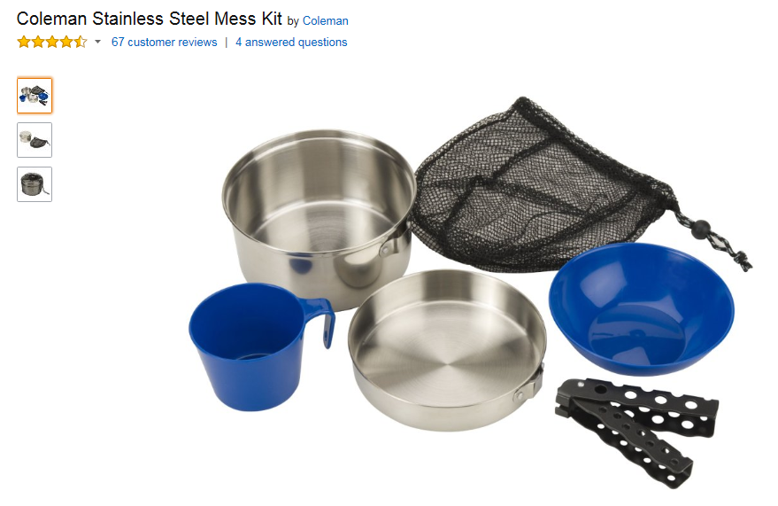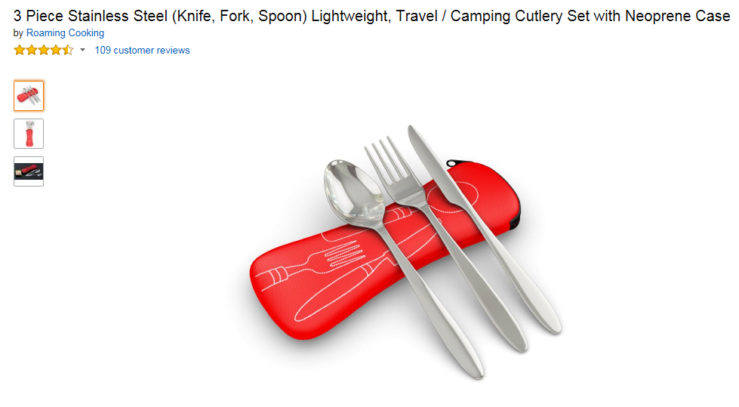
2. Water bottle that can be hung using carabineer. We typically do not use disposable cups. Boys should carry a water bottle.
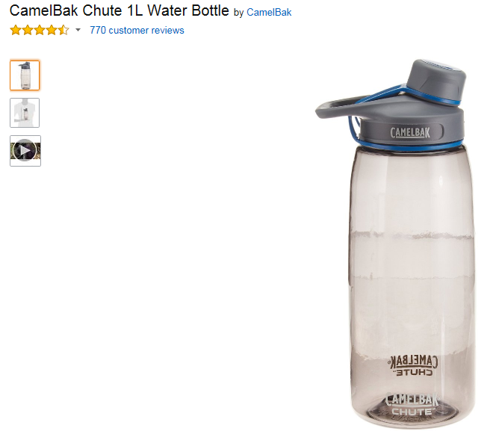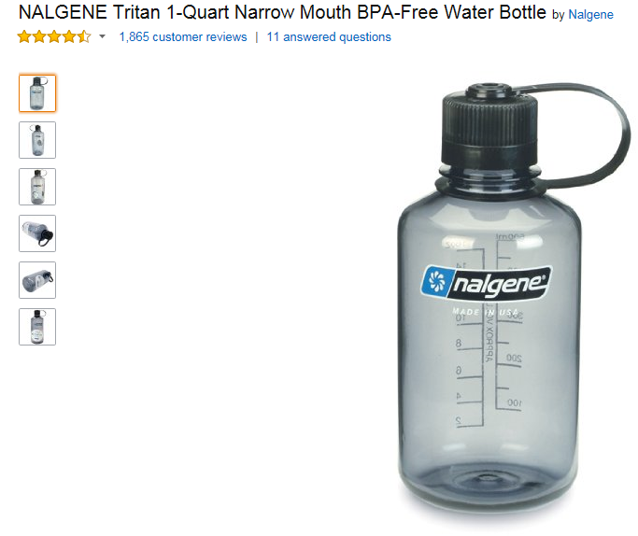
3. Hot drink mug with lid, preferably insulated. It does not matter if metal or plastic, but on those cold nights or mornings, hot chocolate warms them up. Make sure it can be hung with a carabineer.
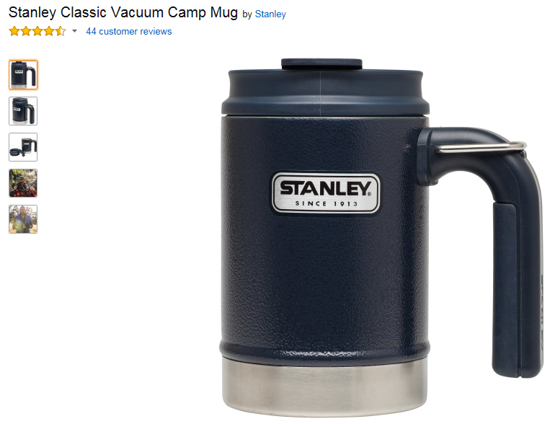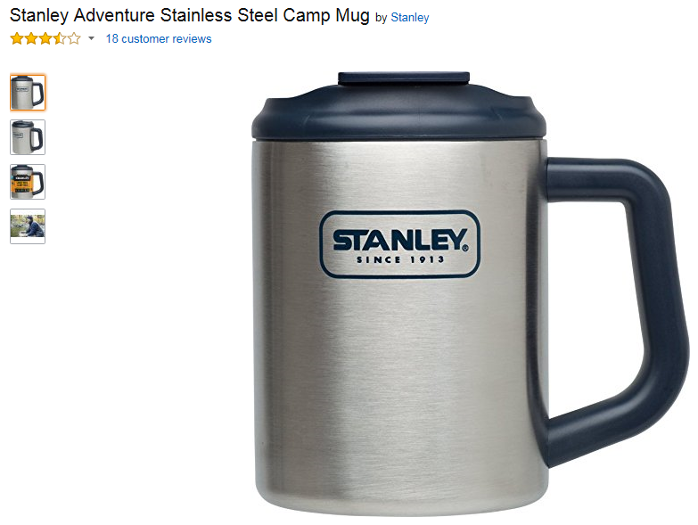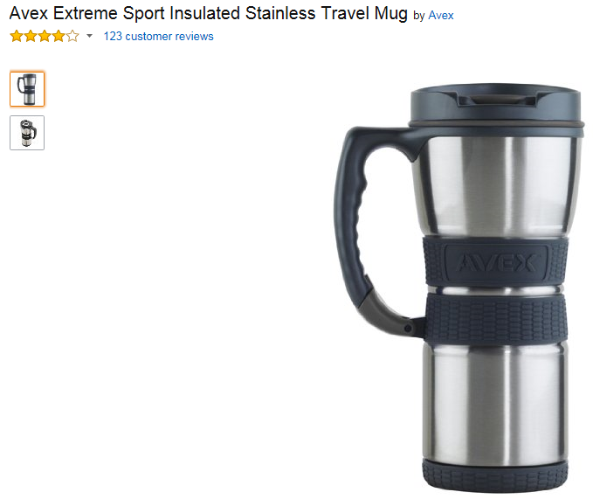
4. Sleeping Bags: For sleeping bags, if it is rated as a 40degree, we usually say it is actually good for 50-55 degree weather. These are great for late Spring, Summer, early Fall camping. For cold weather camping, we recommend eventually purchasing a zero degree or 20 degree sleeping bag. In addition, they make fleece sleeping bag liners which go inside. These are fairly cheap at $18 but offer an additional 10 degrees of warmth when inserted inside the sleeping bag. When it is very hot in summer time, many boys just use the fleece liner only. Also, many buy a cheap small "fleece" blanket from Walmart that they can throw over their heads in winter camping if they don't like wearing a winter hat. For cold weather camping, the following brands are very reputable: LL Bean, Cabelas, The North Face, Kelty, Marmot
https://www.campmor.com/c/s/gear/sleeping-bags-and-gear/sleeping-bags
Https://www.llbean.com
Https://www.cabelas.com
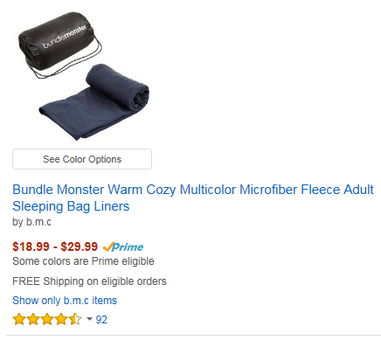
5. Sleeping Pad: Get the larger wider pads (30 inch or wider, 72 inch or longer)
1. NO: We DO NOT recommend standard air mattresses. They provide no real insulation for cold weather camping, are bulky, and take too long to inflate. Also, the old "egg crate" sleeping bags are also an option, but if it rains and the tent leaks, they soak up water like a sponge so usually is not recommended.
2. BEST: The best is the self inflating air pads that are compressible foam and when you open the air valves, it self-inflates. Most are 1 inch, 1.5 inch, 2 inch, or 3 inches deep and are waterproof
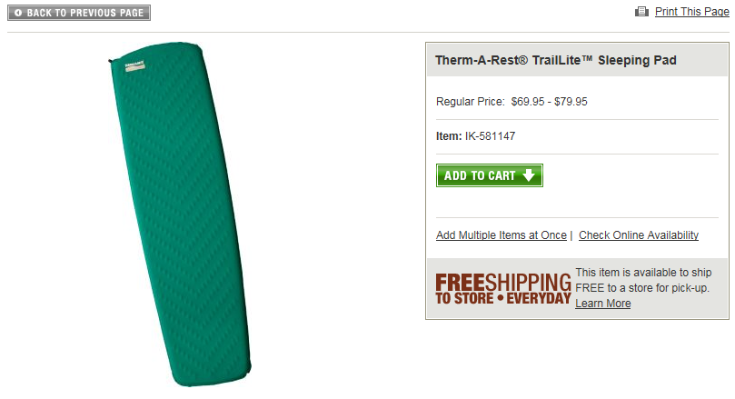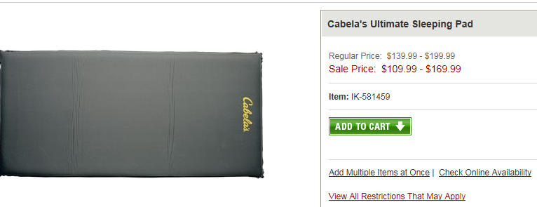
3. BETTER: (HARD NON INFLATING WATERPROOF FOAM) The other option is a foam only sleeping pad (non- inflating) but tend to be harder.
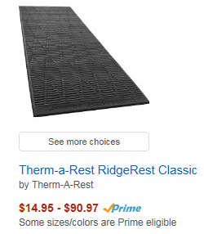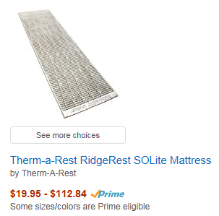

6. Rain Coat: You never know when it will rain, and they should be prepared for hours in the rain. This means both rain jacket and rain pants. We recommend "frogg toggs" rain suits that are sold at Walmart. They are ultralight, breathable, very compact. They are also cheap.
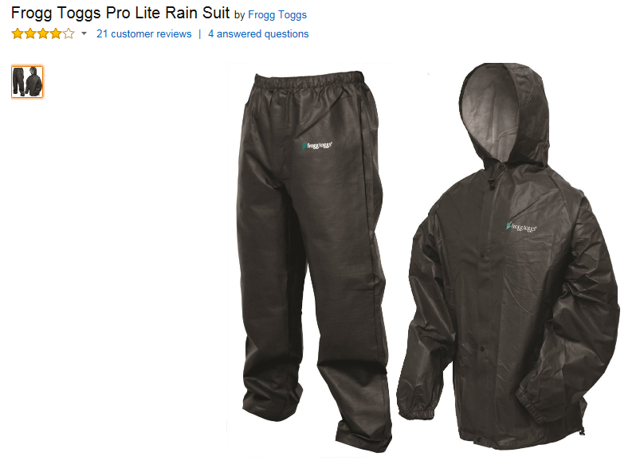
7. Backpack: For the first 1-2 years, any bag will do. However, if they stick with scouts, a backpack will be better for storing and segregating items. In some camping locations, they will be hauling their gear in for up to 1/4 of a mile. As they get older, they will be going on backpacking trips of 3-4 miles.
8. Flashlights: While we have 1-2 lanterns in the trailer, the boys mainly use flashlights. Each boy should have a "hands free" headlamp. Also, 1-2 small pocket flashlights for the tent, and/or a small tent flashlight. The rule of 3 applies here: if you have three flashlights, one will have batteries that die, one flashlight will break, and one last one will hopefully work. Bring spare batteries (just small 4 pack but put in ziplock bag to keep dry).
9. Multiple Shoes: Preferably semi-waterproof like summer hiking boots, leather work boots, etc. Sneakers are fine in summer time.
10. Leatherman and/or Foldable Pocket Knife: The boys will have to “re-earn” the badge to use both knives and axes, called the Totem Chip. The younger boys really do not need a knife in the first half of the year. Also, the scout trailer comes with numerous hatchets, axes, and camp saws, so no need to buy those.
11. Fire Starter: This is not needed right away, and they can borrow from the leaders if needed. It is recommended to eventually buy one.
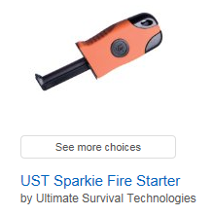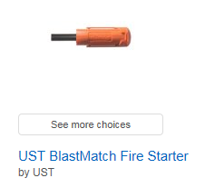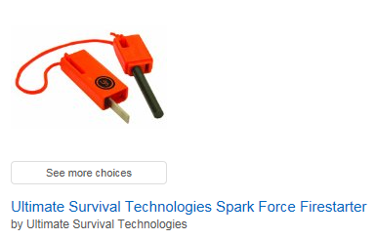
12. Compass: This is not needed right away, but we usually practice navigation during hikes, etc a few times a year.
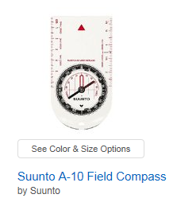
OTHER INFORMATION:
1. FIRST AID KITS: We have CPR qualified adults, and if they are out in the deep woods, the adults take a special "Wilderness First Aid" course. We always carry a first aid kit with all the band aids we need in the trailer and with us. For camp trips <72 hours, you will not need a doctor's physical (but you will need one for BSA week long camp). For <72 hours, we just need each parent to fill out a BSA medical information form annually, or as conditions change. One of the most important items we need to know is any medications your scout takes, and any allergies (epipen), or asthma, etc.
2. SEASONAL CAMPING ITEMS (SUMMER): We recommend baseball cap to keep bugs off head and sun shading. Bring bug repellant, but try to buy small liquid pump containers or lotion. Avoid spray cans as they are large, and flammable around fire. Pack sun tan lotion as necessary.
3. SEASONAL CAMPING ITEMS (WINTER):
Long Underwear (multiple pairs): Have a pair for the day, but at bedtime, they should put dry long underwear on, and even sweatpants and sweatshirts (non-hoodie so they don't get lumpy) on for bed. When it gets cold, even your body sweat can make you 5-10 degrees colder if slightly damp at night.
Wool socks and winter hat: You lose a lot of heat out of your head and feet. It is almost mandatory to sleep with a winter hat and wool socks on in cold weather camping.
Waterproof Insulated Boots: Make sure they can wear with wool socks. We often hike in rain/mid and snow. Frost bite starts in fingers and toes. Most boys find hunting hiking boots that may be leather/rubber, waterproof canvas. For cold weather camping, regular sneakers should be left at home. Other boots like Muck that are rubber/neoprene are also great.

